# PeopleSafe - Special Dispensing Instructions ScripTalk, Braille, Large Font and Signature

General Information

Viewing Dispensing Instructions on the PeopleSafe Patient Profile

Requests for Prescription Labels for the Vision Impaired

Reporting Issues with the ScripTalk Station

Requests for Counseling Sheets for Previous Orders

Requests for Signature Required or NO Signature Required

California Language Requests (Chinese, Korean, Russian, or Vietnamese)

New York Language Requests (Chinese, Italian, or Russian)

Requests for Blister Packs (Client: GEHA Only)

Resolution Time

Related Documents

**Description:** Process for viewing, handling member requests or inquires about special dispensing options.

|  |
| --- |
| General Information |

 View the Dispensing Instructions on the **Patient Profile** screen prior to requesting any changes.

We have partnered with En-Vision America to provide members with ScripTalk prescription labels and ScripView large font labels. These options are available for active members utilizing our PBM Home Delivery Service.

ScripTalk prescription labels should be offered as the preferred option to all members inquiring about Braille or large font labels, or any other offering for those with visual impairment.

**Note:** Large font counseling sheets are not available, just large font labels.

* If the member also wants to place an order, **do not place it** until after you have completed this entire process for requesting alternative label formats.
* If the member makes a special handling request **after** submitting an order, advise the member that these options are not available for orders that have already shipped.
* We can set up their account so that the ScripTalk, ScripView (large font), Braille labels, Signature Required or not Required, Spanish Language Requests from any state, California Language Requests (Chinese, Korean, Russian, or Vietnamese), New York Language Requests (Chinese, Italian, or Russian) or Blister packs (GEHA only) are provided for future orders.
* Notify members any special dispensing instructions can add extra processing times to orders.
* Counseling sheets can ONLY be created for the following languages: English, Spanish, Mandarin, Italian, Russian, Korean, and Vietnamese.
* If a member would like to remove large fonts please reach out to Senior Team to get notes added to account.

Top of the Document

|  |
| --- |
| Viewing Dispensing Instructions on the PeopleSafe Patient Profile |

This feature allows the user to review Dispensing Instructions for the member/beneficiary’s prescriptions.

**Note:** When reviewing the Patient Profile, if there are Dispensing Instructions for the member/beneficiary, the box adjacent is checked.

To review Dispensing Instructions, Access PeopleSafe, click **Maintain Patient Profile** then **Dispensing Instructions** hyperlink.

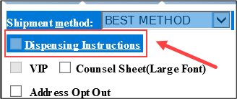

**Result:** The Dispensing Instructions that apply to this member/beneficiary displays. This is a “Read Only” pop up screen.

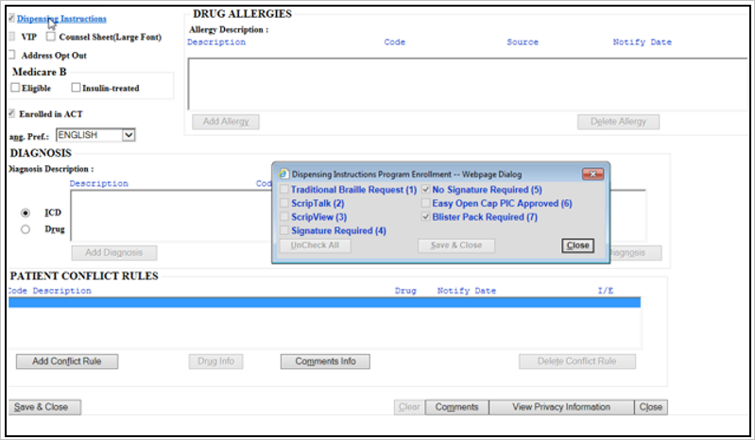

* If no Dispensing Instructions are included, the box to the left will not be checked.

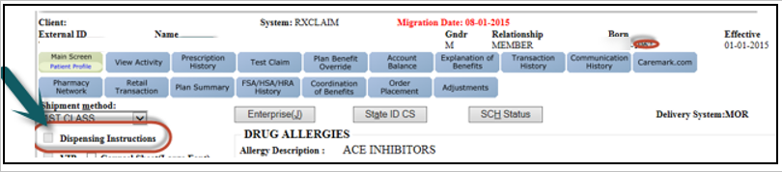

**Note:** Contact the [Senior Team (016311)](https://thesource.cvshealth.com/nuxeo/thesource/#!/view?docid=9eef064d-c7d7-42f7-9026-1497496b4d51) for a procedural transfer when a member requests to add or change special dispensing options.

Top of the Document

|  |
| --- |
| Requests for Prescription Labels for the Vision Impaired |

Perform the steps below when a member inquires about options for the vision impaired:

|  |  |  |  |  |
| --- | --- | --- | --- | --- |
| **Step** | **Action** | | | |
| **1** | Validate the member has a need for alternative label formats due to blindness, visual impairment, dyslexia, or some other condition that makes it difficult to read standard labels.  If the member wants to place an order, **do NOT place it until** you have completed this entire process for requesting alternative label formats. If the member makes a special handling request aftersubmitting an order, advise the member that these options are not available for orders that have already shipped. We can set up their account so that the ScripTalk, ScripView (large font), or Braille labels are provided for future orders.  **Note:** It is possible to request more than one type of label for Prescriptions. | | | |
| **If...** | | **Then...** | |
| Yes | | Proceed to **Step 3**. | |
| No | | Inform the member the labels are reserved for those with conditions requiring the use of alternative label formats. | |
| **2** | Inform the member that we can provide prescription labels for use with En-vision America’s ScripTalk Station. A ScripTalk Station can be mailed to the member free of charge.  **About ScripTalk:**  ScripTalk is available for all prescriptions filled through PBM Home Delivery Service and is also available for CVS.com, Specialty and Retail pharmacy prescriptions.   * The ScripTalk Station provides those who cannot read the information on their prescriptions a safe and easy way to manage their personal healthcare. Press a button and place the special Talking Label over the reader. A voice speaks all the information printed on the label, such as: * Drug Name, Dosage, & Instructions * Warnings & Contraindications * Pharmacy Information * Doctor Name * Prescription Number & Date * The ScripTalk Station uses Radio Frequency Identification (RFID) and text-to-speech technology. A thin antennae and microchip embedded within the label are programmed with all the printed information. Because the data is stored in the label itself, it can be used on any size bottle, box, vial, tube, or other prescription container.   **ScripTalk Station Features:**   * + Lightweight and Portable   + Natural Voice   + Earphone Jack for Privacy   + One Touch Operation   + Read as Many Times as Needed   + Adjustable Volume   + Works with any Prescription   + Multiple Languages     ScripTalk Station is the only audible prescription reading device to meet all federal requirements listed under the Federal Drug and Cosmetic Act (FDCA), Americans with Disabilities Act (ADA) and Health Information Portability and Accountability Act (HIPAA). | | | |
| **If member…** | | | **Then...** |
| Is Interested in ScripTalk | | | Proceed to the **Step 3**. |
| Has further questions about ScripTalk | | | Advise the member that they can contact En-Vision America at **1-800-890-1180**. Their business hours are Monday thru Friday, 8:30 am to 5:00 pm (CT). Refer to <https://www.envisionAmerica.com>. |
| Is Not interested in ScripTalk | | | * Advise that of other alternatives, such as Braille labels or ScripView (large font) labels. * Determine which option the member would like. * Contact the [Senior Team (016311)](https://thesource.cvshealth.com/nuxeo/thesource/#!/view?docid=9eef064d-c7d7-42f7-9026-1497496b4d51) to enter instructions for the member’s prescriptions to be provided with Braille or Large Font labels.   **Note:** Notify the Senior Team if the member wants to place an order today. |
| **3** | Determine if the member already has a ScripTalk Station from En-Vision America.  **Note:** There is another company that supplies a talking label device, but **our labels only work with** **the** **ScripTalk Station** provided by En-Vision America. | | | |
| **If...** | **Then...** | | |
| Yes | * Advise the member they can use their existing ScripTalk Station. * Advise the member that you will submit a request to have their prescription labels include the sensor at the bottom of the bottle that enables it to be read by the ScripTalk Station when placed over the reader. * Contact the [Senior Team (016311)](https://thesource.cvshealth.com/nuxeo/thesource/#!/view?docid=9eef064d-c7d7-42f7-9026-1497496b4d51) to enter instructions for the member’s prescriptions to be updated for use with ScripTalk.   **Note:** Notify the Senior Team for a procedural transfer; if the member wants to place an order today. | | |
| No | * Advise the member that you will request a ScripTalk Station be mailed to them. * Advise the member that you will also submit a request to have their prescription labels include the sensor at the bottom of the bottle that enables it to be read by the ScripTalk Station when placed over the reader. * Fill out the form online at <https://www.envisionamerica.com/>.   + Select **ScriptAbility**.   + Select **for Pharmacies**.   + Select **Patient Approval Form**. * Include the member’s shipping and contact information, enter CVS Caremark Pharmacist in the CVS Caremark Contact field, [CustomerService@Caremark.com](mailto:CustomerService@Caremark.com) in the email field and then submit the form (images below).   **Result:** En-Vision America contacts the member to confirm shipping address and mail out a device within 7 days, or as early as 3 days if needed.   * Contact the [Senior Team (016311)](https://thesource.cvshealth.com/nuxeo/thesource/#!/view?docid=9eef064d-c7d7-42f7-9026-1497496b4d51) to enter instructions for the member’s prescriptions to be updated for use with ScripTalk.   **Note:** Notify the Senior Team for a procedural transfer if the member wants to place an order today. | | |

Top of the Document

|  |
| --- |
| Reporting Issues with the ScripTalk Station |

If a member reports issues with the ScriptTalk Station, advise them to contact En-Vision America at **1-800-890-1180**. Their business hours are Monday thru Friday, 8:30 am to 5:00 pm (CT) or visit their website at <https://www.envisionAmerica.com>.

**Note:** If member wants to stop using ScripTalk labels, reach out to the Senior Team to notify the Mail pharmacy to discontinue sending labels.

Top of the Document

|  |
| --- |
| Requests for Counseling Sheets for Previous Orders |

CVS Caremark Home Delivery Pharmacy does not print the Participant Counseling Form for refills. All mandatory messaging will now appear on members’ invoices.

**Note:** If the prescription was originally shipped over 30 days ago, counseling sheets cannot be reprinted.

Perform the steps below to order counseling sheets for orders that have already shipped (Regular or Braille).

|  |  |
| --- | --- |
| **Step** | **Action** |
| **1** | Send an RM task for the following:   * **Task Category:** Fulfillment * **Task Type:** Counseling Sheet * **Queue:** Select the most recent dispensing pharmacy for the prescription * **Notes:** If Braille counseling sheets are requested, indicate this in the task notes.   The following information is entered on the Braille Label:   * Rx #<xx> Date * Prescriber name * Patient name * Directions * Drug * Qty <xx> Refills   **Note:** The Braille label has limited room.  **Example:** |

Top of the Document

|  |
| --- |
| Requests for Signature Required or NO Signature Required |

Perform the steps below:

|  |  |  |  |
| --- | --- | --- | --- |
| **Step** | **Action** | | |
| **1** | Determine the member’s request. | | |
| **If the member requests…** | **Then…** | |
| A signature be required for a prescription order | Check if the order is for any C2 Controlled Substances.  **Note:** Follow the same instruction if not a Controlled Substance. | |
| **If…** | **Then…** |
| Yes | Notify the member that when placing an order for any C2 Controlled Substance, a signature is required for delivery. |
| No | Contact the [Senior Team (016311)](https://thesource.cvshealth.com/nuxeo/thesource/#!/view?docid=9eef064d-c7d7-42f7-9026-1497496b4d51) to enter instructions for the member’s prescriptions to be provided with Signature Required.  **Note:** Notify the Senior Team for a procedural transfer if the member wants to place an order today.  If the member wants to place an order, **do NOT place it until** after completing this entire process for requesting alternative label formats.   * If the member makes a special handling request **after** submitting an order, advise the member that these options are not available for orders that have already shipped. We can set up their account so that Signature Required or Not Required is available for future orders. |
| NO signature be required for a prescription order | Check if the order is for any C2 Controlled Substances. | |
| **If…** | **Then…** |
| Yes | Notify the member that when placing an order for any C2 Controlled Substance, a signature will be required for delivery. |
| No | Notify the member that no signature will be required for their order.  This is also the process for a non-controlled substance.  **Note:** If a member requests a signature required on all medications, contact the Senior Team to enter instructions for the member’s prescriptions to be provided with Signature Required. |

Top of the Document

|  |
| --- |
| California Language Requests (Chinese, Korean, Russian, or Vietnamese) |

Perform the steps below:

|  |  |  |
| --- | --- | --- |
| **Step** | **Action** | |
| **1** | Refer to the table below for instructions specific to the type of request. | |
| **If the member requests...** | **Then...** |
| Chinese, Korean, Russian, or Vietnamese **and** resides in California | * Click **Maintain Patient Profile**. * Change the language preference drop-down to **the requested language**. * Click **Save & Close**. |
| Chinese, Korean, Russian, or Vietnamese **and does NOT reside in California** | Advise the member that we cannot set up their account so that Chinese, Korean, Russian, or Vietnamese will be provided for their orders. |
| Any language other than Chinese, Korean, Russian, or Vietnamese, regardless of location | Advise the member that we cannot set up their account so that language will be provided for future orders. |

Top of the Document

|  |
| --- |
| New York Language Requests (Chinese, Italian, or Russian) |

Perform the steps below:

|  |  |  |
| --- | --- | --- |
| **Step** | **Action** | |
| **1** | Refer to the table below for instructions specific to the type of request. | |
| **If the member requests...** | **Then...** |
| Chinese, Italian, or Russian **and** resides in New York | * Click **Maintain Patient Profile**. * Change the language preference drop-down to **the requested language**. * Click **Save & Close**. |
| Chinese, Italian, or Russian and **does NOT** reside in New York | Advise the member that we cannot set up their account so that Chinese, Italian, or Russian will be provided for their orders. |
| Any language other than Chinese, Italian, or Russian, regardless of location | Advise the member that we cannot set up their account so that language will be provided for future orders. |

Top of the Document

|  |
| --- |
| Requests for Blister Packs (Client: GEHA Only) |

Perform the steps below when a member inquires about blister packs for GEHA:

|  |  |  |
| --- | --- | --- |
| **Step** | **Action** | |
| **1** | Navigate to the **Maintain Patient Profile** screen to verify if the member has been enrolled in blister pack deliveries. | |
| **If Member’s Special Dispensing box...** | **Then...** |
| Is checked **and** a high priority comments has been added to the profile | Member is enrolled for blister pack deliveries. Proceed to step 2. |
| Is not checked | To complete enrollment, have the Senior Team send a request to [GEHA@cvshealth.com](mailto:GEHA@cvshealth.com) to initiate enrollment for blister packs.  **DO NOT place the order until** after completing this entire process for requesting alternative label formats. |
| **2** | Validate the member has a Stop See on account entered by GEHA for blister packaging.   * If there is a Stop See on account, place order via standard process. | |

Top of the Document

|  |
| --- |
| Resolution Time |

For previous order requests, the member should expect to receive the labels or sheets up to 2 business days of the time the materials are requested.

Top of the Document

|  |
| --- |
| Related Documents |

[Customer Care Abbreviations, Definitions, and Terms (017428)](https://thesource.cvshealth.com/nuxeo/thesource/#!/view?docid=c1f1028b-e42c-4b4f-a4cf-cc0b42c91606)

[Log Activity/Capture Activity Codes (005164)](https://thesource.cvshealth.com/nuxeo/thesource/#!/view?docid=bdac0c67-5fee-47ba-a3aa-aab84900cf78)

**Parent Document:** [CALL 0049 Customer Care Internal and External Call Handling](https://policy.corp.cvscaremark.com/pnp/faces/DocRenderer?documentId=CALL-0049)

Top of the Document

Not to Be Reproduced or Disclosed to Others without Prior Written Approval

**ELECTRONIC DATA = OFFICIAL VERSION / PAPER COPY = INFORMATIONAL ONLY**